AI-Based Screening System for Diabetic Retinopathy, Hypertensive Retinopathy, and Glaucoma

Week - 1

Mashal Areej
Arsal Saeed

1. Executive Summary
This report documents the deliverables completed during week 1 of the five-week project to build AI-based retinal disease screening system. The system is designed to detect diabetic retinopathy, glaucoma, and hypertensive retinopathy from a single fundus photograph, providing clinics with an instant, browser-based AI screening tool that requires no specialist on site and costs nothing to run.

At the end of week 1, the following have been built, tested, and confirmed working end to end:
- Data pipeline loading and preprocessing 91,630 fundus images from APTOS 2019 and EyePACS
- Custom CNN model architecture trained from scratch in PyTorch
- ONNX model export confirmed working and deployed in the Node.js backend
- Node.js Express backend serving real AI predictions from uploaded fundus images
- Clinical-grade browser frontend with patient information form and results display
- PDF report generation producing a structured A4 clinical document from the browser

The full pipeline from image upload to diagnosis result has been tested with real fundus photographs and confirmed working. Training on the merged 91,630-image dataset is currently in progress on Kaggle.

2. Deliverables Completed - Week 1

Deliverable | File | Status
Data pipeline | training/dataset.py | Complete and tested
Dataset merge script | training/merge_datasets.py | Complete and tested
CNN model architecture | training/model.py | Complete and tested
Training script | training/train.py | Complete / run ongoing on Kaggle
ONNX export script | training/export.py | Complete and tested
Node.js backend | backend/server.js | Complete and tested
Clinical UI | backend/public/index.html | Complete and tested
PDF report generation | Integrated in index.html via jsPDF | Complete and tested
GitHub repository | github.com/arsalsaeed27/AI-Based-Screening-System | Active, both team members pushing

3. Data Pipeline
3.1 Datasets used

Dataset | Images | Classes | Used for
APTOS 2019 | 2,930 | 0 to 4 DR severity | DR training baseline
Resized EyePACS | 88,700 | 0 to 4 DR severity | DR volume and rare class balancing

3.2 Preprocessing steps
Every fundus image passes through the following pipeline before being fed to the model:
- Black border crop using OpenCV contour detection to isolate the circular retina region
- Resize to 224x224 pixels to match the model input dimensions
- CLAHE (contrast-limited adaptive histogram equalization) to enhance blood vessel visibility
- Normalization of pixel values to the 0 to 1 range
- Augmentation on training set: horizontal flip, random rotation up to 15 degrees, brightness and contrast jitter
4. Model Architecture
4.1 Diabetic Retinopathy CNN
A custom convolutional neural network built from scratch in PyTorch. No pretrained weights are used at any point. The full architecture is:

Layer | Type | Output channels
Block 1 | Conv2d → BatchNorm2d → ReLU → MaxPool2d | 32
Block 2 | Conv2d → BatchNorm2d → ReLU → MaxPool2d | 64
Block 3 | Conv2d → BatchNorm2d → ReLU → MaxPool2d | 128
Block 4 | Conv2d → BatchNorm2d → ReLU → MaxPool2d | 256
Block 5 | Conv2d → BatchNorm2d → ReLU → MaxPool2d | 512
Pooling | AdaptiveAvgPool2d to 1x1 | 512
FC 1 | Linear 512 → 256 · ReLU · Dropout 0.5 | 256
FC 2 (output) | Linear 256 → 5 | 5 class probabilities

- Total trainable parameters: 1,703,173
- Input dimensions: 3 x 224 x 224 (RGB, normalized)
- Output: 5 softmax probabilities for ICDR grades 0 through 4

5. Training Progress
5.1 Configuration

Parameter | Value
Loss function | CrossEntropyLoss with class frequency weights
Optimizer | Adam
Learning rate | 0.001
Batch size | 32
Epochs planned | 30
Checkpoint frequency | Every 5 epochs saved as a checkpoint
Training platform | Kaggle notebook
Dataset | Merged APTOS + EyePACS · 91,630 images · 80/20 train/val split

5.2 Results so far
The following epoch-level results have been recorded from the current training run on the merged dataset:

Epoch | Train Loss | Train Acc | Val Loss | Val Acc
1 | 1.6104 | 38.5% | 1.5987 | 73.2%
2 | 1.5977 | 46.2% | 1.5693 | 57.6%
3 | 1.5734 | 34.5% | 1.5346 | 32.6%
4 | 1.5532 | 32.6% | 1.4859 | 59.8%
.. | .. | .. | .. | ..
28 | 1.1685 | 53.9% | 1.1860 | 73.2%

The validation loss is dropping consistently across epochs (1.5987 to 1.186), confirming the model is genuinely learning. The validation accuracy fluctuation is expected with heavily imbalanced data.
The training run is ongoing

5.3 APTOS-only baseline
Before starting the merged dataset run, a baseline training run on APTOS 2019 alone was completed for 26 epochs, reaching 69% validation accuracy. That model was exported to ONNX and is currently deployed in the backend as the working model for the UI demonstration.

6. Backend
The backend is a Node.js Express server that handles image uploads, preprocessing, AI inference, and result delivery. It loads the ONNX model once at startup so inference is fast on every subsequent request.

6.1 API endpoints

Endpoint | Method | Description
GET /health | GET | Returns system status, used to confirm server is running
POST /predict | POST | Accepts a fundus image upload and returns AI prediction as JSON

6.2 Prediction pipeline in Node.js
- Image received via Multer file upload middleware
- Sharp resizes the image to 224x224 and extracts raw RGB pixel data
- Pixel values normalized to 0 to 1 and arranged in CHW format (channels first)
- ONNX Runtime runs the model and returns 5 raw logit scores
- Softmax applied to convert logits to probabilities
- JSON response returned with predicted class, severity label, confidence, all 5 scores, and referral guidance

6.3 Sample response
{
"predicted_class": 0,
"severity_label": "No DR",
"confidence": 0.66,
"scores": [0.66, 0.15, 0.10, 0.03, 0.06],
"referral": "Re-screen in 12 months"
}

7. System Interface
The frontend is a single-page clinical application served by Express from the backend/public/ folder. It runs in any modern browser without installation. The interface uses plain HTML, CSS, and JavaScript with no framework dependency. Screenshots of the live running system are shown below.

7.1 Idle state — awaiting upload
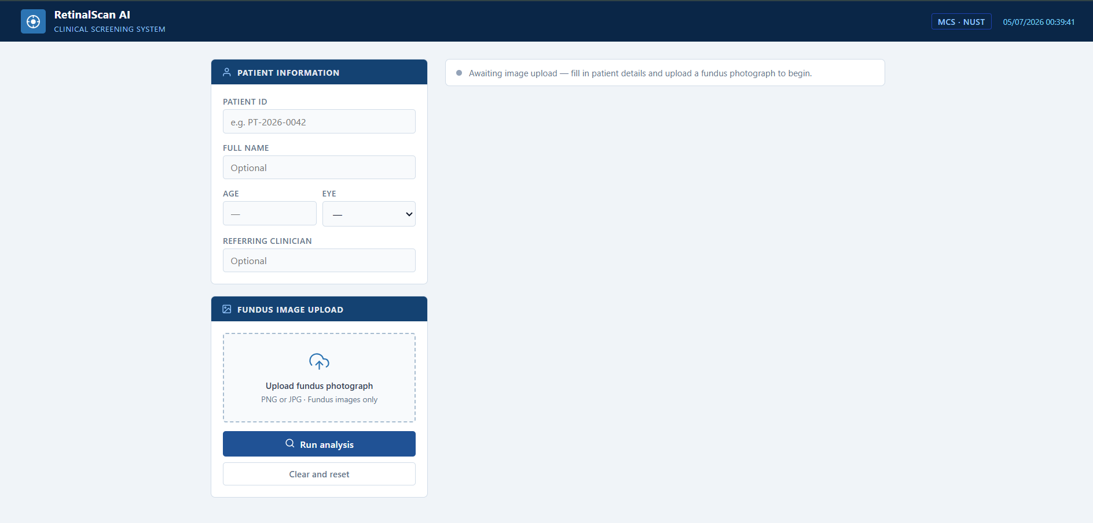
Figure 1: System interface idle state — patient information form and upload zone

7.2 Image loaded — ready to analyse
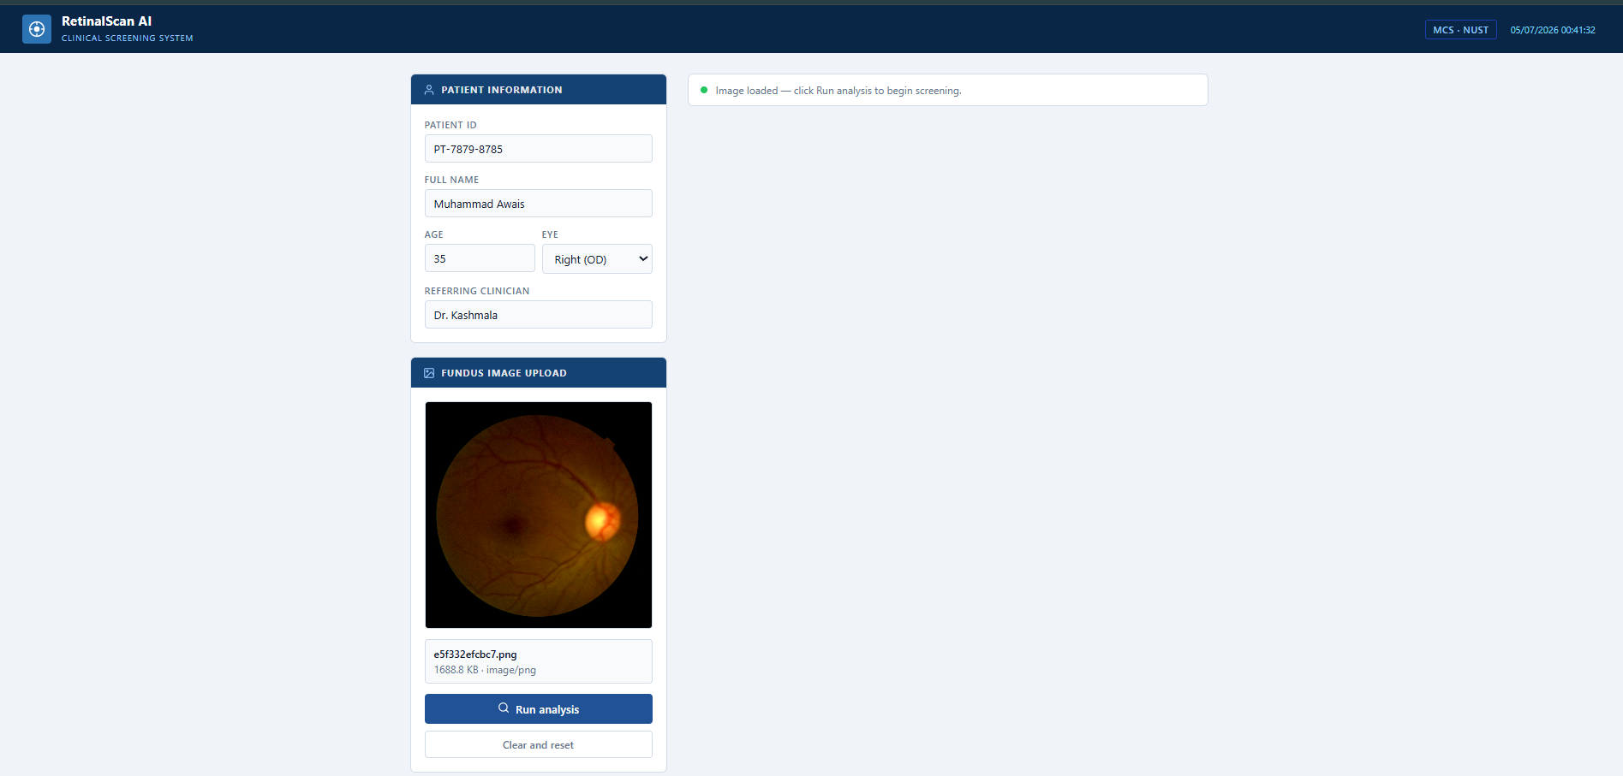
Figure 2: Fundus photograph loaded — real image from the APTOS dataset

7.3 Analysis result
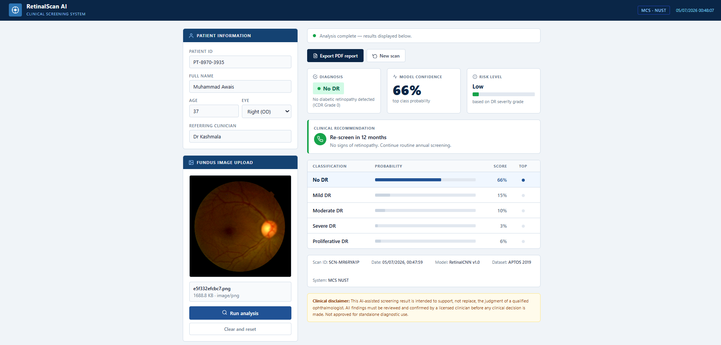
Figure 3: Full analysis result — No DR · 66% confidence · Re-screen in 12 months recommendation

The result panel includes:
- Diagnosis badge color-coded by ICDR severity grade
- Model confidence percentage
- Risk level meter from Minimal to Critical
- Clinical recommendation with referral urgency text
- Class probability table with inline bar charts for all 5 DR grades
- Scan metadata including Scan ID, date, model version, dataset, and institution
- Clinical disclaimer consistent with ICDR guidelines

8. PDF Clinical Report
The Export PDF Report button generates a structured A4 clinical document entirely in the browser using the jsPDF library. This is not a screenshot or a print of the web page — it is a programmatically built document with full control over layout, typography, and content. The report is saved with a filename that includes the patient ID and scan ID for traceability.

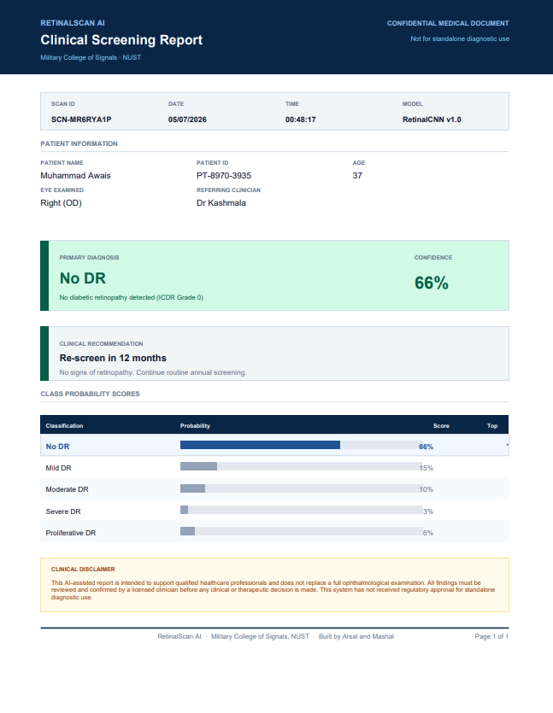
Figure 4: PDF clinical report generated by the system for patient Muhammad Awais

The report contains the following sections:
- Navy header bar with RETINALSCAN AI branding, institution name, and CONFIDENTIAL tag
- Scan metadata bar: Scan ID, date, time, model version, and dataset
- Patient information grid: name, patient ID, age, eye examined, and referring clinician
- Primary diagnosis box: severity label, ICDR grade, and confidence percentage — color coded by severity
- Clinical recommendation: referral action text based on published ICDR guidelines
- Class probability scores: all 5 DR grades with inline bar charts and percentage scores
- Clinical disclaimer: full text consistent with medical AI best practices
- Footer: institution name, builder attribution, and page number

9.Tech Stack

Layer | Technology | Purpose
Data preprocessing | OpenCV, NumPy | Black border crop, CLAHE contrast, resize, normalization
Model training | PyTorch (from scratch) | Custom CNN and U-Net — zero pretrained weights
Model export | ONNX opset 18 | Single self-contained portable file
Backend | Node.js, Express | REST API handling uploads and serving predictions
Inference | onnxruntime-node | CPU-only inference — no GPU required at clinic
Image handling | Sharp, Multer | Server-side resize and file upload
Frontend | Plain HTML, CSS, JS | Clinical UI with PDF report export via jsPDF
Version control | GitHub | Shared repo — both team members actively pushing
Training compute | Kaggle T4 GPU | 30 free GPU hours per week, checkpoint supported
Dataset storage | Google Drive | Persistent checkpoint and dataset storage across sessions
Hosting (planned) | Hugging Face Spaces | Free deployment, browser accessible, no credit card

